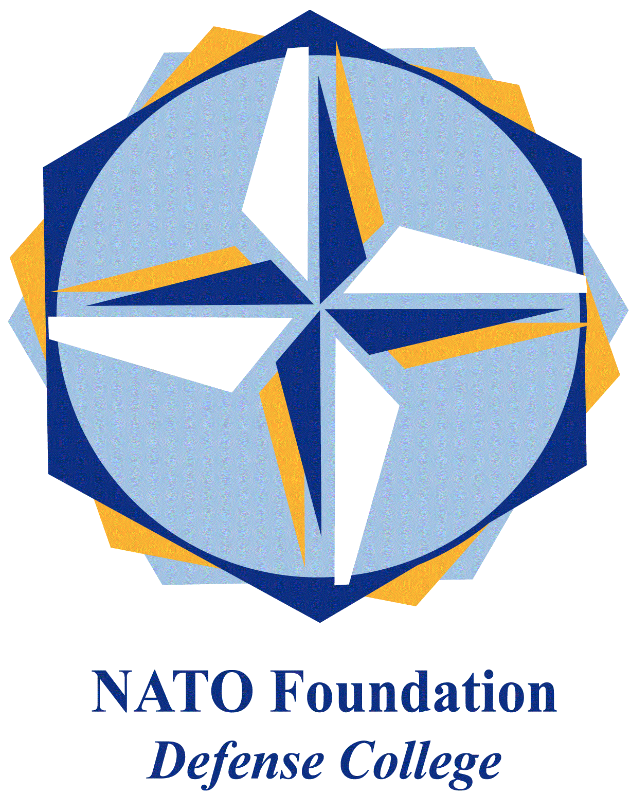
NATO DEFENSE COLLEGE FOUNDATION
STRATEGIC TRENDS
September 2015
MAGHREB
Libya’s peace deal: take it or leave it
The political climate in Libya has relatively improved in the last three months. Since July 2015 the UN-brokered negotiations have yielded significant outcomes. The main reason for this acceleration has been the growing risk related to activities of the Islamic State (ad-Dawla, Wilayet of Tripolitania, Fezzan and Barqa; aka ISIS, DAESH) terrorist group in the country and the international attention to the refugee crisis.
Another important factor for the recent improvements in the political dialogue has been the September 20 deadline announced by the United Nations. Under the pressure of this deadline, the efforts of the Head of the United Nations Support Mission in Libya (UNSMIL), Bernardino León, produced a power-sharing agreement in Skhirat, Morocco, on July 11. The deal, which provides for a government of national accord (GNA) and recognizes the Tobruk based House of Representatives (HoR) as the sole Libyan legislative body, was signed by HoR and different municipalities, but was opposed by the General National Congress (GNC) in Tripoli.
The draft was object of further discussions and amendments in the next weeks. The talks stressed an increasing divide inside both coalitions, as shown by the unexpected resignation of the GNC head of delegation Saleh Makhzoum on August 26. However, after negotiations in Istanbul and Geneva, on September 13 Bernardino León announced that the rival governments reached a ‘consensus’ on the main elements of the political agreement. As a consequence, about 25 lawmakers, who boycotted HoR during the last year, agreed to return to the elected parliament.
However, this significant step was not enough to obtain a comprehensive peace deal by the UN deadline. Even though the UN Security Council approved an extension of UNSMIL mandate until March 15, 2016, on September 21 León declared that the UN work was over and that both factions must accept the draft deal, providing a list of names for the GNA, or decline it. The UNSMIL head took the opportunity to condemn the recent escalation of violence in Benghazi, where the Libyan National Army (LNA) led by Khalifa Haftar launched a new operation against the Islamists in the city. The timing of the operation convinced León of Haftar’s attempt to undermine negotiations.
In this complex contest, it is really difficult to make any prediction. Initial rumours about a change at the top of UNSMIL are spreading and several sources indicate the Head of the UN Stabilization Mission in the Democratic Republic of Congo (MONUSCO) Martin Kobler as a possible replacement for León. Besides the continuing interferences by regional powers, the main obstacle to a power sharing agreement is internal. On October 20 the term of the HoR expires, but it is not impossible that an agreement will be found before.
If a peace-deal will not be achieved in time, it will be difficult for the international community to sustain the legitimacy of the Tobruk based parliament, and the results so far obtained by UNSMIL risk to be re-discussed again, also because spoilers are rather present in the Libyan political scene.

